DANI WILDE
NEW ALBUM – LIVE AT BRIGHTON ROAD
Released June 2017 on VizzTone Label Group
British Blues Award winner Dani Wilde burst onto the International blues scene in 2007, opening for Jools Holland at The Royal Albert Hall and signing to prestigious blues record label Ruf Records. Since then she has toured extensively across the UK, Europe, America, Canada, and Africa. USA concerts have included headline shows under her own name, and performances with girl group ‘Girls With Guitars’ alongside Samantha Fish and Cassie Taylor. The group’s 2012 record, produced by Mike Zito in Berlin, was a hit in Europe; the single “Bitch” reaching the Number 1 spot in the iTunes blues charts in Italy.
Live at Brighton Road finds Dani Wilde performing live in the studio with her touring band, featuring her brother Will Wilde on harmonica. Dani is performing mostly original songs, split into an acoustic and electric set. For her fans this will be a long-anticipated treat, for newcomers it will serve as a beautiful introduction to the depth of spellbinding talent and impact of this young British Blues Lady.
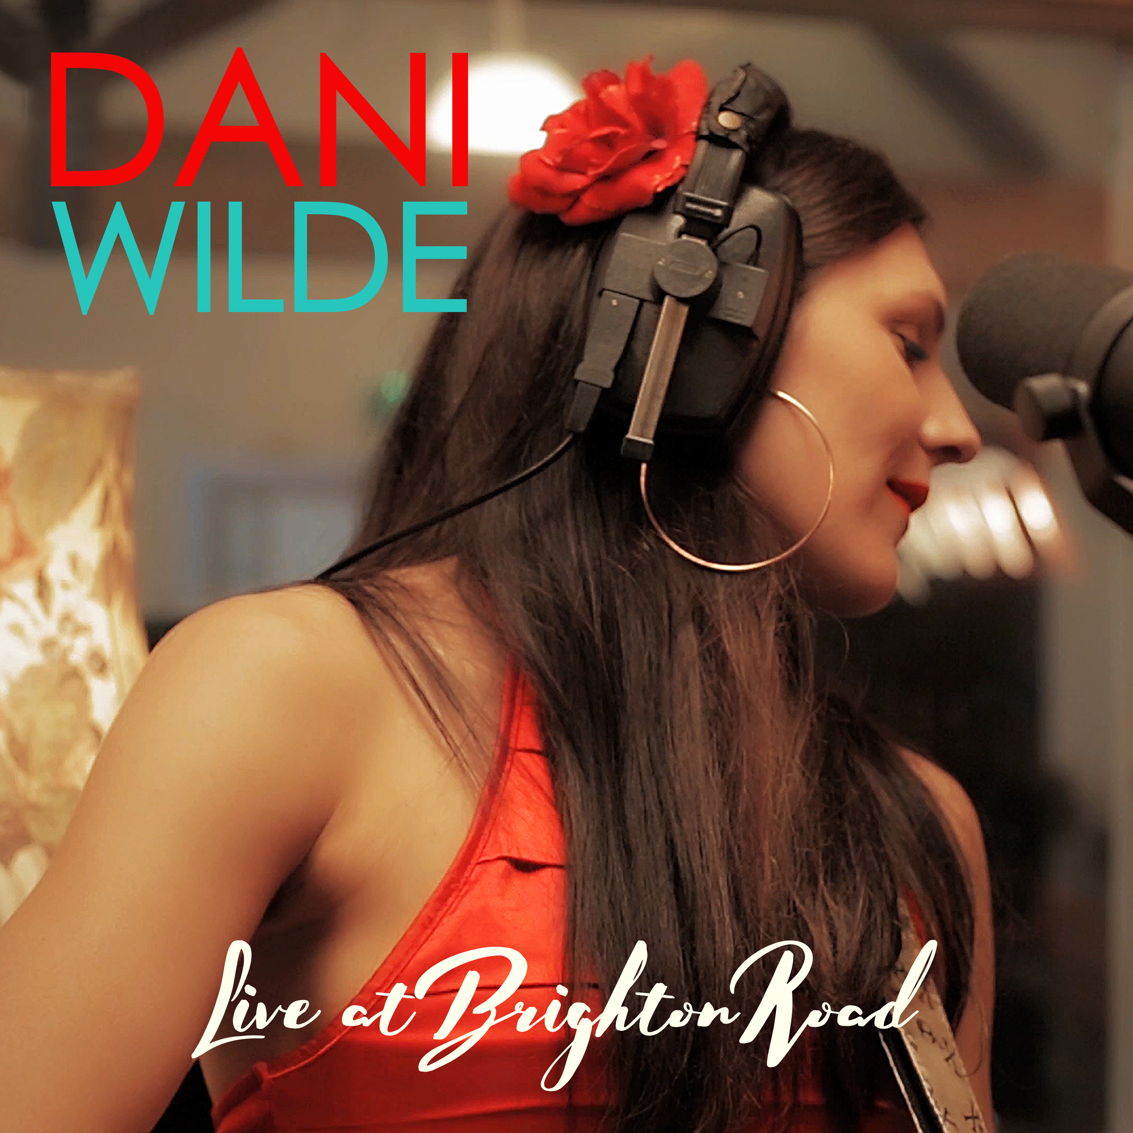

Dani Wilde – Live at Brighton Road
Format: CD & DVD
Label: Vizztone
Release date: 16 June 2017
Tracks
01 Bumble Bee (Live)
02 My Old Man (Live)
03 Glorious Day (Live)
04 The Living Years (Live)
05 Electricity (Live)
06 Deeper Than Black (Live)
07 Hound Dog (Live)
08 High On Your Love (Live)
09 Don’t Quit Me Baby (Live)
10 Refugee (Live)

